**Practical No. 8**

**MINI PROJECT**

**Aim:** To implement a mini project on Online Examination Portal.

**Output:**

**1**.**HOME PAGE:**



**2.Code to establish connection with the database “eexamination”**

<?php

DEFINE('DB_USER','root');

DEFINE('DB_PSWD','');

DEFINE('DB_HOST','localhost');

DEFINE('DB_NAME','eexamination');

$dbcon= mysqli_connect(DB_HOST,DB_USER,DB_PSWD,DB_NAME);

/*

if(!$dbconn)

{

die('error connecting to database');

}

echo('you have connected successfully');

*/

?>

**3.STUDENT SIGN UP PAGE:**

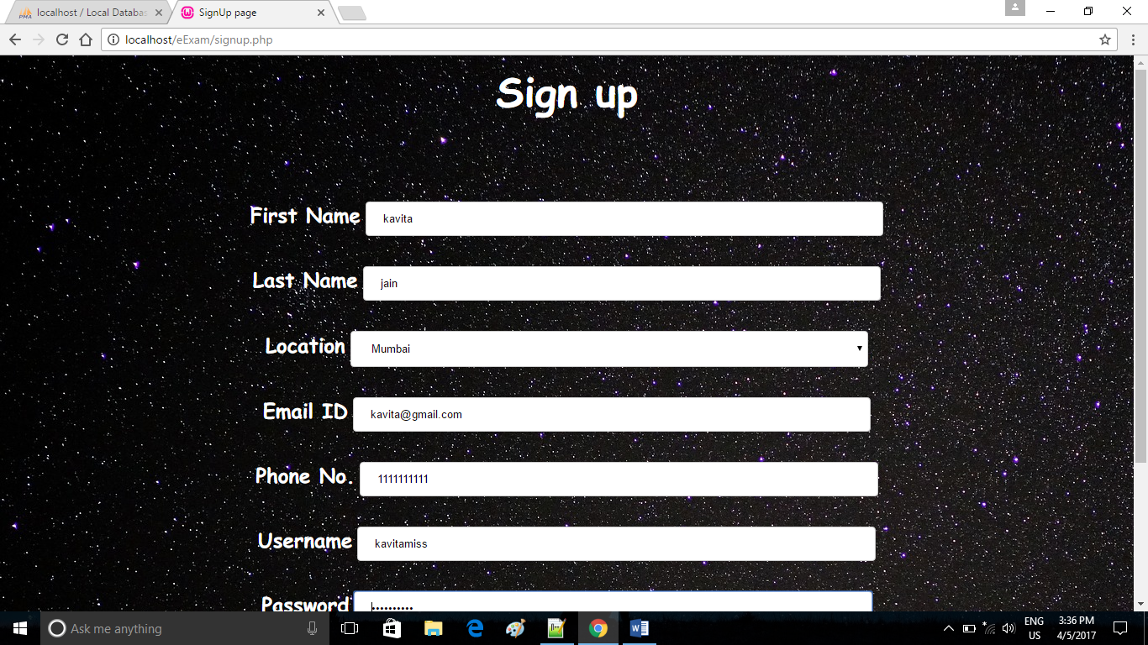

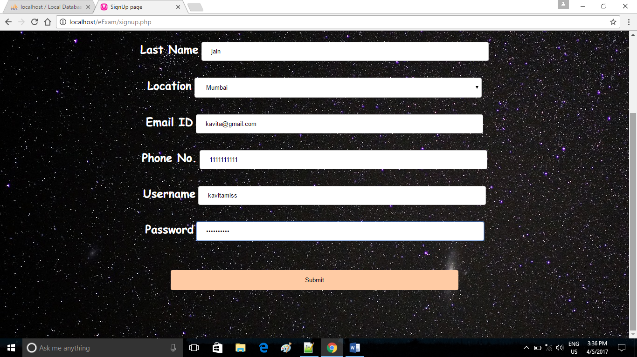

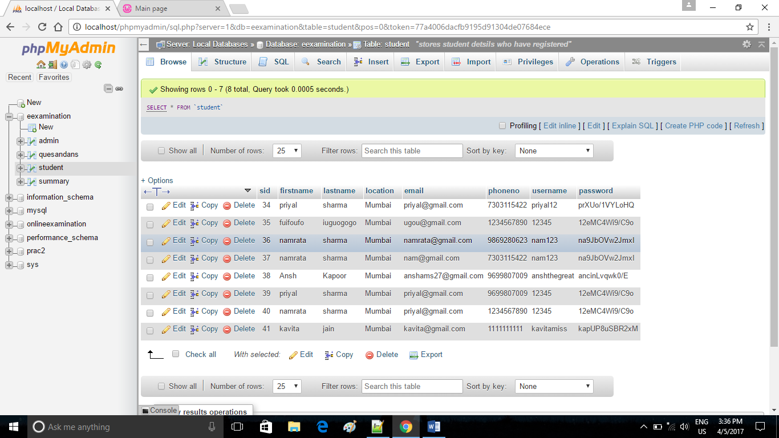

**4. Code to insert student details in student table:**

<?php

if(isset($_POST['submitted'])){

include('connect-mysql.php');

$fname=$_POST["firstname"];

$lname=$_POST["lastname"];

$loc=$_POST["loc"];

$email=$_POST["emailid"];

$phno=$_POST["phoneno"];

$user=$_POST["username"];

$pass=$_POST["password"];

$salt = substr($user, 0, 2);

$crypted_pass = crypt($pass, $salt);

$sqlinsert="INSERT INTO student(firstname,lastname,location,email,phoneno,username,password)VALUES('$fname','$lname','$loc','$email','$phno','$user','$crypted_pass')";

if(!mysqli_query($dbcon, $sqlinsert)){

die('error inserting new record');

header("Location:signup.php");

}

header("Location:homepg.php");

}

?>

**5.STUDENT LOGIN PAGE**

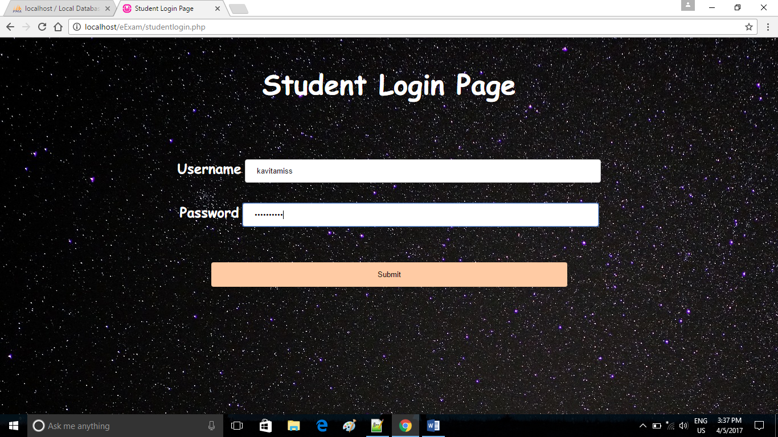

**Code to authenticate student**

<?php

$conn = new mysqli("localhost","root","","eexamination");

if($conn -> connect_error){

echo "Error connecting .Please try again".$conn -> connect_error;

}

else{

$username=$_POST["username"];

$password=$_POST["password"];

$salt=substr($username, 0,2);

$newcryptedpassword=crypt($password,$salt);

// echo "My custom encyrpter passworrd ".$newcryptedpassword."<br>"; $sql="SELECT * FROM student WHERE username='$username'";

$result=$conn->query($sql);

if($result-> num_rows >0){

$row=$result->fetch_assoc();

if($row["password"]===$newcryptedpassword){

header("Location: givetest.php");

echo "Authenticated";

}

else{

header("Location: studentlogin.php");

echo "Fake";

}

}

else{

header("Location: studentlogin.php");

echo "No Such Username";

}

}

?>

**6.QUESTIONS PAGE**

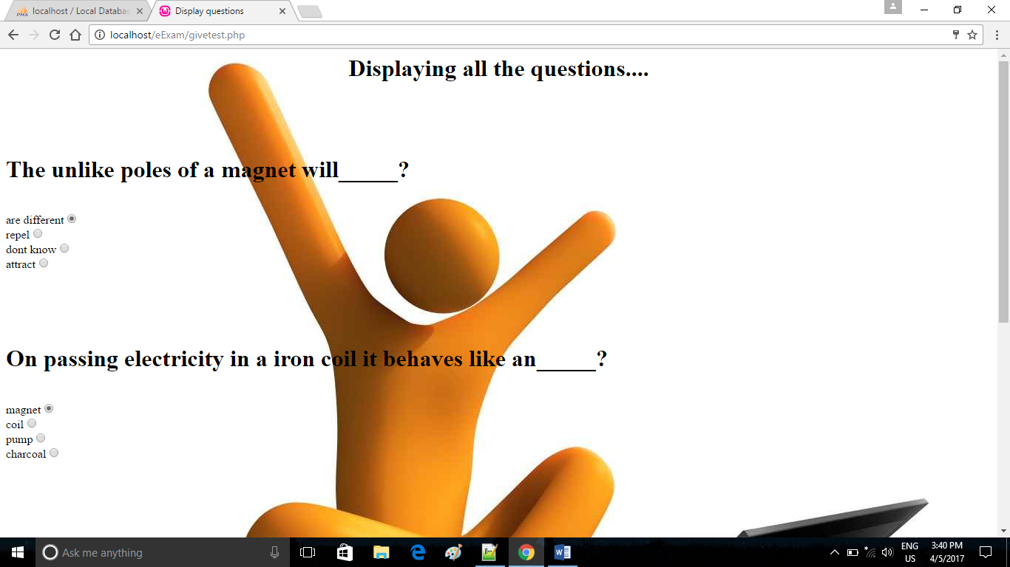

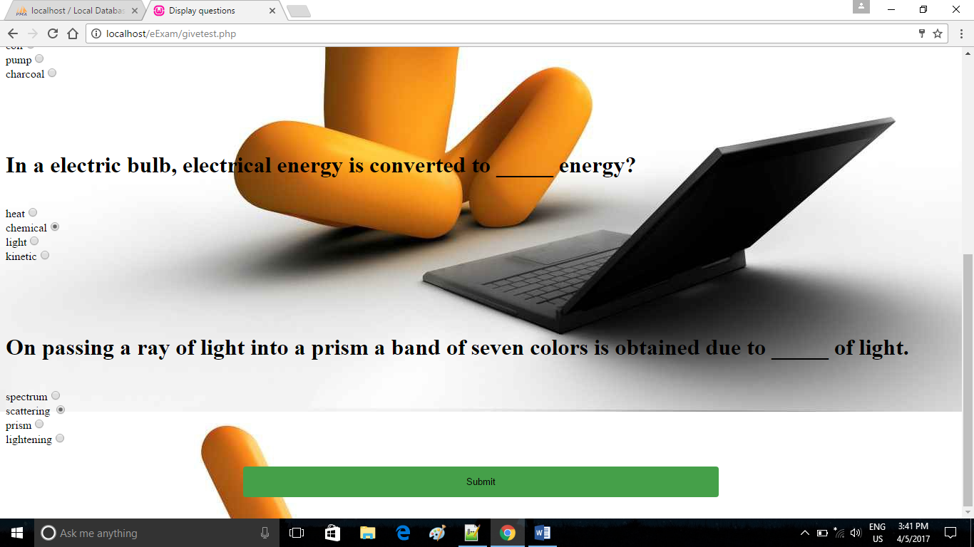

**7.Code to display questions from quesandans table**

<?php

//I will First build my dataset

$conn = new mysqli("localhost","root","","eexamination");

if($conn -> connect_error){

echo "Error connecting .Please try again".$conn -> connect_error;

}

else{

$sqlget="Select * from quesandans";

$result=$conn->query($sqlget);

}

?>

<html>

<head><title>Display questions</title>

<style type="text/css">

table{

background-color: white;

align: center;

}

th{

border-bottom: 5px solid #000;

}

td{

border-bottom: 2px solid #666;

}

input[type=submit] {

width: 50%;

background-color: red;

color: Black;

padding: 14px 20px;

margin: 8px 0;

border: none;

border-radius: 4px;

cursor: pointer;

}

input[type=submit]:hover {

background-color: #45a049;

}

</style>

</head>

<body background="3.jpg" >

<h1 align="center">Displaying all the questions....</h1>

<?php //////to make radio box

/*include('connect-mysql.php');

$sqlget="Select qid, question, options from quesandans";

$sqldata=mysqli_query($dbcon,$sqlget) or die('error getting data');

echo "<table>";

echo "<form>";

echo "<tr><th>QID</th><th>Questions</th><th>Options</th></tr>";

while($row=mysqli_fetch_array($sqldata,MYSQLI_ASSOC)){

echo"<tr><td>";

echo $row['qid'];

echo"</td><td>";

echo $row['question'];

echo"</td><td>";

echo ?><input type="radio" value=<?php echo"$row['options']";?>/>

<?php

echo"</td></tr>";

}

echo "</form>"

echo"</table>";

*/ ?>

<form action="evaluateresult.php" method="POST">

<?php

while ($row=$result->fetch_assoc()) {

?>

<div style="margin-top: 100px;">

<h1><?php echo $row["question"]; ?></h1><br>

<?php echo $row["a"]; ?>

<input type="radio" name="<?php echo $row["qid"]; ?>" value="a"><br>

<?php echo $row["b"]; ?>

<input type="radio" name="<?php echo $row["qid"]; ?>" value="b"><br>

<?php echo $row["c"]; ?>

<input type="radio" name="<?php echo $row["qid"]; ?>" value="c"><br>

<?php echo $row["d"]; ?>

<input type="radio" name="<?php echo $row["qid"]; ?>" value="d"><br>

</div>

<?php

}//while loop closes

?>

<h1 align="center">

<input type="submit" value= "Submit"></h1>

</form>

</body>

</html>

**8.RESULT PAGE**

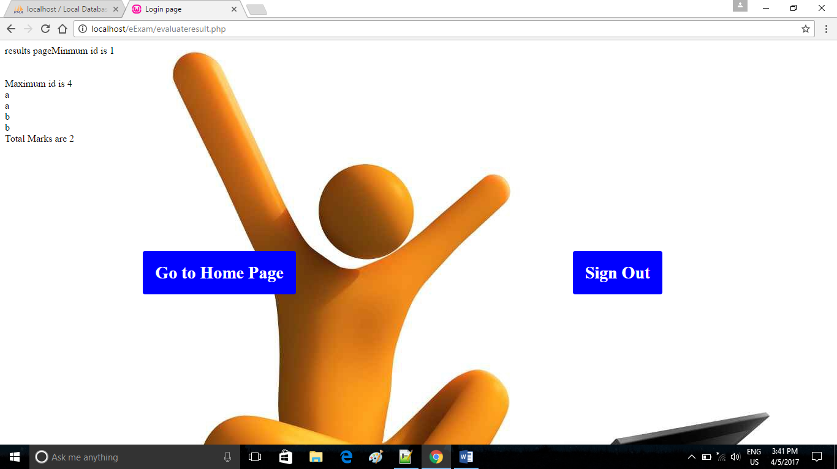

**9.Code to calculate result by verifying answers from quesandans table**

<?php

echo "results page";

$conn = new mysqli("localhost","root","","eexamination");

if($conn -> connect_error){

echo "Error connecting .Please try again".$conn -> connect_error;

}

else{

$marks=0;

$getorderquery="SELECT min(qid) AS minId

FROM quesandans";

$result=$conn->query($getorderquery);

$row=$result->fetch_assoc();

echo "Minmum id is ".$row["minId"]."<br>";

echo"<br>";

$minid=$row["minId"];

$getorderquery="SELECT MAX(qid) AS maxId

FROM quesandans";

$result=$conn->query($getorderquery);

$row=$result->fetch_assoc();

echo("<br>");

echo "Maximum id is ".$row["maxId"]."<br>";

$maxId=$row["maxId"];

for($i=$minid;$i<=$maxId;$i++){

echo $_POST[$i]."<br>";

$getrightoption="SELECT * FROM quesandans where qid='$i'";

$result=$conn->query($getrightoption);

$row=$result->fetch_assoc();

if($_POST[$i]==$row["answer"]){

$marks++;

}

}

echo "Total Marks are ".$marks;

}

?>

**10. ADMIN LOGIN PAGE**

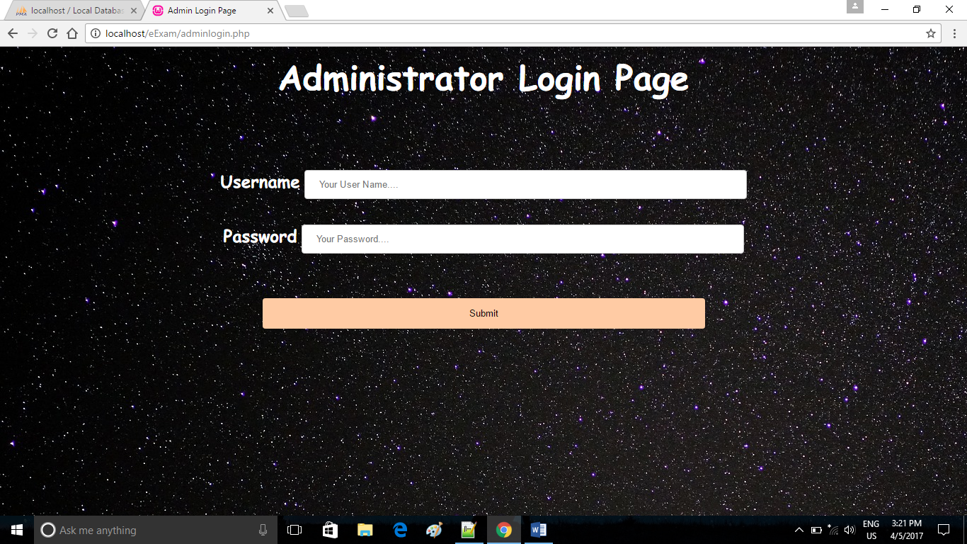

**11. Code for admin authentication**

<?php

//connect with database

$conn = new mysqli("localhost","root","","eexamination");

if($conn -> connect_error){

echo "Error connecting .Please try again".$conn -> connect_error;

}

else{

$username=$_POST["username"];

$password=$_POST["password"];

$sql="select * from admin where ausername='$username' and apassword='$password' ";

$result=$conn->query($sql);

if($result-> num_rows >0){

header("Location:adminrights.php");

}

else{

header("Location:adminlogin.php");

}

}

?>

**12.ADMIN FUNCTIONALITIES**

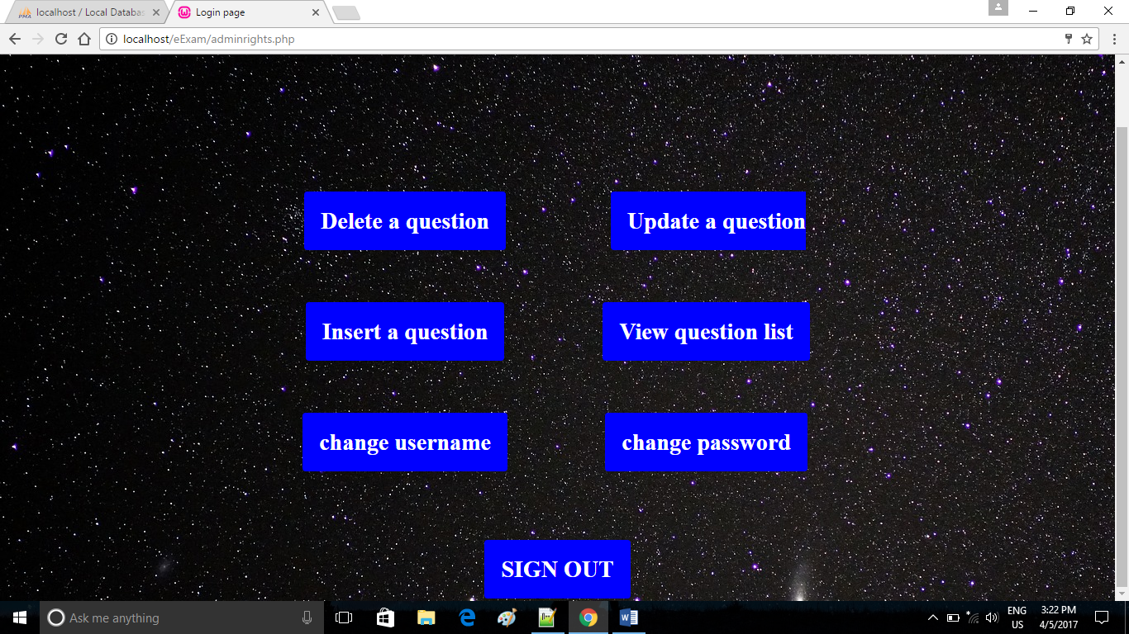

**13. INSERT QUESTION**

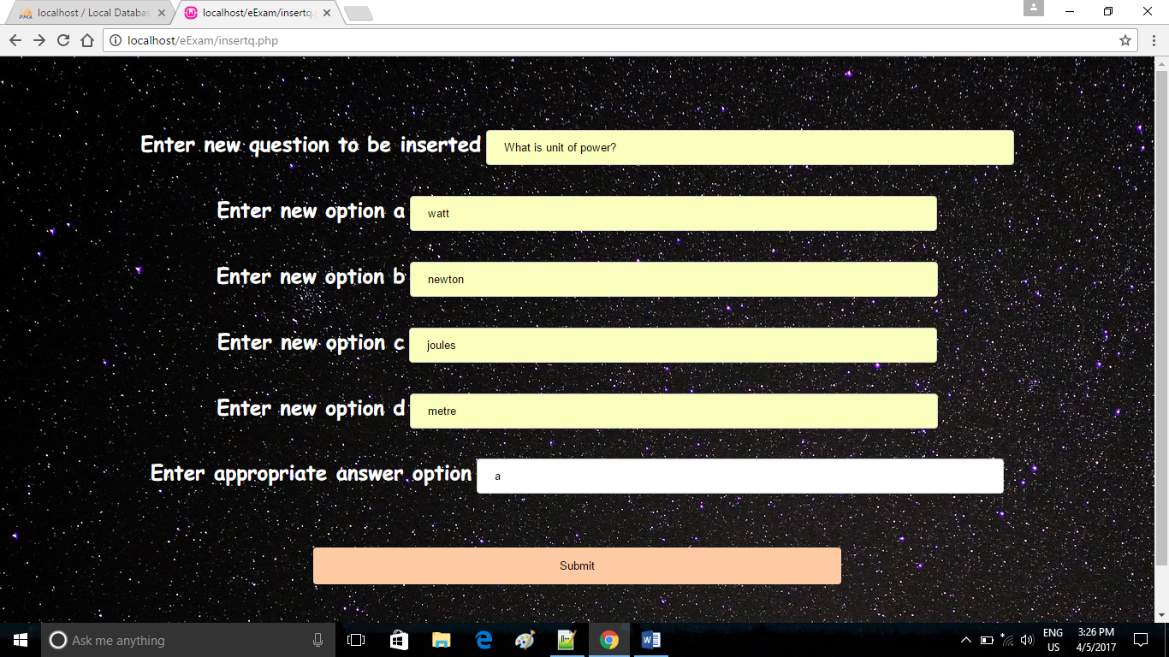

**14.Code to insert data in quesandans database**

<?php

if(isset($_POST['submitted'])){

include('connect-mysql.php');

$question=$_POST["question"];

$optiona=$_POST["optionsa"];

$optionb=$_POST["optionsb"];

$optionc=$_POST["optionsc"];

$optiond=$_POST["optionsd"];

$answer=$_POST["answer"];

$sqlinsert="INSERT INTO quesandans(question,a,b,c,d,answer)VALUES('$question','$optiona','$optionb','$optionc','$optiond','$answer')";

if(!mysqli_query($dbcon, $sqlinsert)){

die('error inserting new record');

header("Location:insertq.php");

}

header("Location:adminrights.php");

}

?>

**15.VIEW QUESTION**

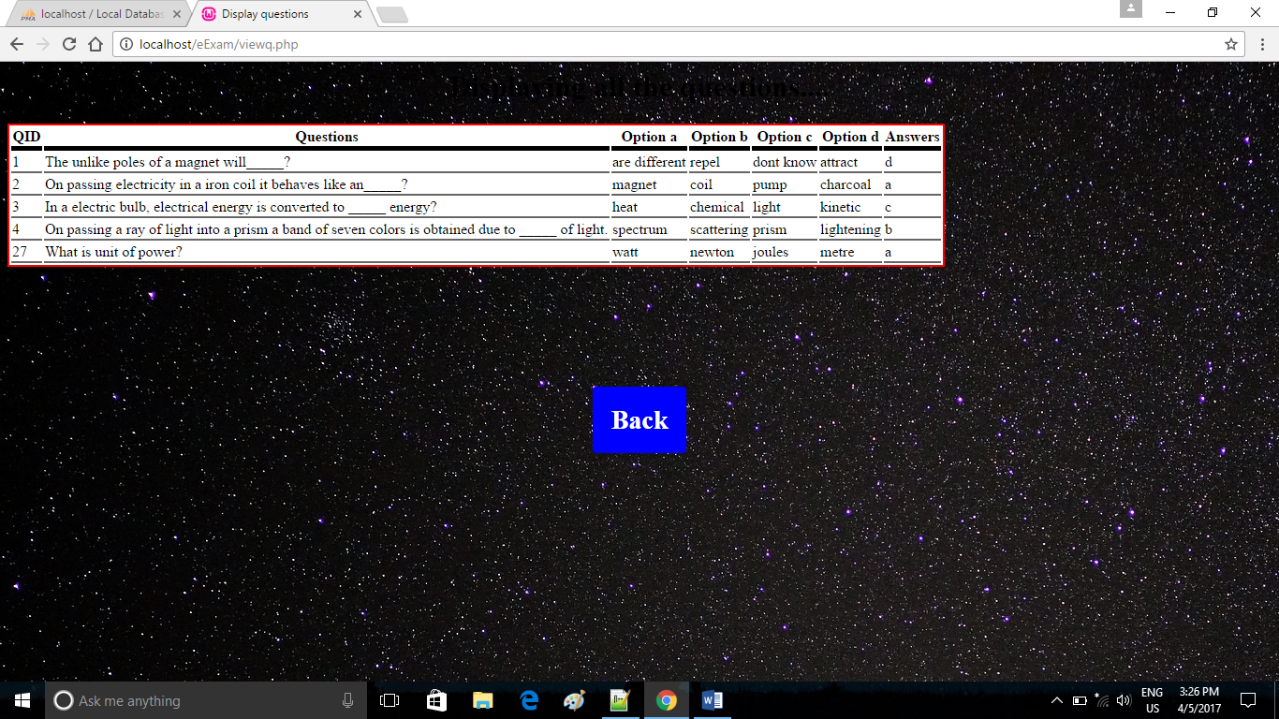

**16.Code to view data from the quesandans table**

<html>

<head><title>Display questions</title>

<style type="text/css">

table{

border: 2px solid red;

background-color: white;

align: center;

}

th{

border-bottom: 5px solid #000;

}

td{

border-bottom: 2px solid #666;

}

.button {

border-radius: 4px;

background-color: blue;

border: none;

color: #FFFFFF;

text-align: center;

font-size: 28px;

padding: 20px;

width: 200px;

transition: all 0.5s;

cursor: pointer;

margin: 5px;

}

.button span {

cursor: pointer;

display: inline-block;

position: relative;

transition: 0.5s;

}

.button span:after {

content: '\00bb';

position: absolute;

opacity: 0;

top: 0;

right: -20px;

transition: 0.5s;

}

.button:hover span {

padding-right: 25px;

}

.button:hover span:after {

opacity: 1;

right: 0;

}

</style>

</head>

<body background="22.jpg">

<h1 align="center">Displaying all the questions....</h1>

<?php

include('connect-mysql.php');

$sqlget="Select * from quesandans";

$sqldata=mysqli_query($dbcon,$sqlget) or die('error getting data');

echo "<table>";

echo "<tr><th>QID</th><th>Questions</th><th>Option a</th><th>Option b</th><th>Option c</th><th>Option d</th><th>Answers</th></tr>";

while($row=mysqli_fetch_array($sqldata,MYSQLI_ASSOC)){

echo"<tr><td>";

echo $row['qid'];

echo"</td><td>";

echo $row['question'];

echo"</td><td>";

echo $row['a'];

echo"</td><td>";

echo $row['b'];

echo"</td><td>";

echo $row['c'];

echo"</td><td>";

echo $row['d'];

echo"</td><td>";

echo $row['answer'];

echo"</td></tr>";

}

echo"</table>";

?>

<br><br><br><br><br><br><br>

<h1 align="center">

<a href="adminrights.php" class="button"><span>Back</span></a></h1>

</body>

</html>

**17.UPDATE QUESTION**

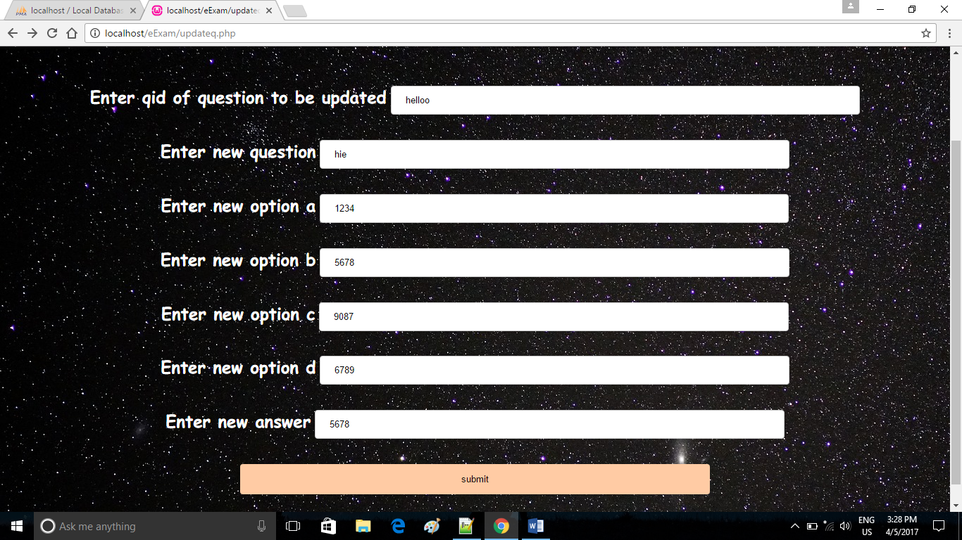

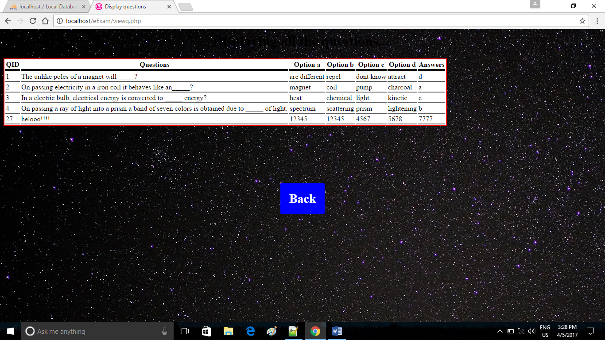

**18.Code to update data in quesandans database**

<?php

if(isset($_POST['submitted'])){

include('connect-mysql.php');

$qid=$_POST["qid"];

$question=$_POST["qname"];

$optionsa=$_POST["optionsa"];

$optionsb=$_POST["optionsb"];

$optionsc=$_POST["optionsc"];

$optionsd=$_POST["optionsd"];

$answer=$_POST["answer"];

$sql1 = "UPDATE quesandans SET question='$question' WHERE qid='$qid'";

$sql2 = "UPDATE quesandans SET a='$optionsa' WHERE qid='$qid'";

$sql3 = "UPDATE quesandans SET b='$optionsb' WHERE qid='$qid'";

$sql4 = "UPDATE quesandans SET c='$optionsc' WHERE qid='$qid'";

$sql5 = "UPDATE quesandans SET d='$optionsd' WHERE qid='$qid'";

$sql6 = "UPDATE quesandans SET answer='$answer' WHERE qid='$qid'";

if(mysqli_query($dbcon, $sql1) && mysqli_query($dbcon, $sql2) && mysqli_query($dbcon, $sql3) && mysqli_query($dbcon, $sql4) && mysqli_query($dbcon, $sql5) && mysqli_query($dbcon, $sql6)){

echo "Records were updated successfully.";

header("Location: adminrights.php");

} else {

// echo "ERROR: Could not able to execute $sq1. " . mysqli_error($dbcon);

}

// Close connection

mysqli_close($dbcon);

}?>

**19.DELETE QUESTION**

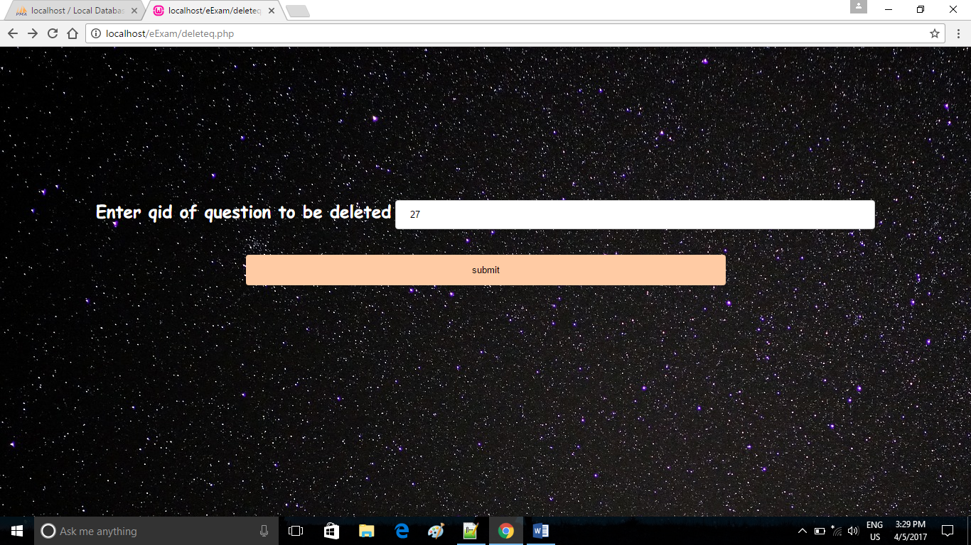

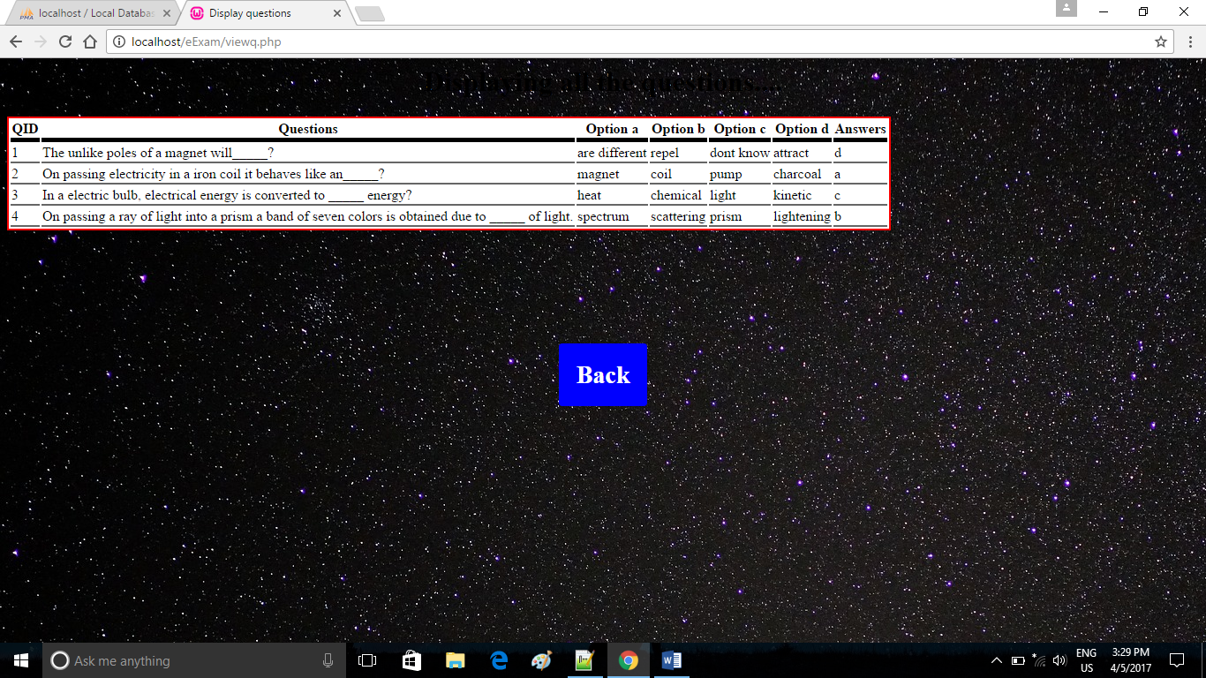

**20.Code to delete a record from quesandans database**

<?php

$qid=$_POST["qid"];

echo $qid;

$conn = new mysqli("localhost","root","","eexamination");

if($conn -> connect_error){

echo "Error connecting .Please try again".$conn -> connect_error;

}

else{

$sql = "DELETE FROM quesandans WHERE quesandans.qid='$qid'";

if($conn->query($sql)===TRUE){

echo "Deleted";

header("Location: adminrights.php");

}

else{

echo "Error";

}

}

?>

**21.CHANGE USERNAME**

**BEFORE CHANGE:**

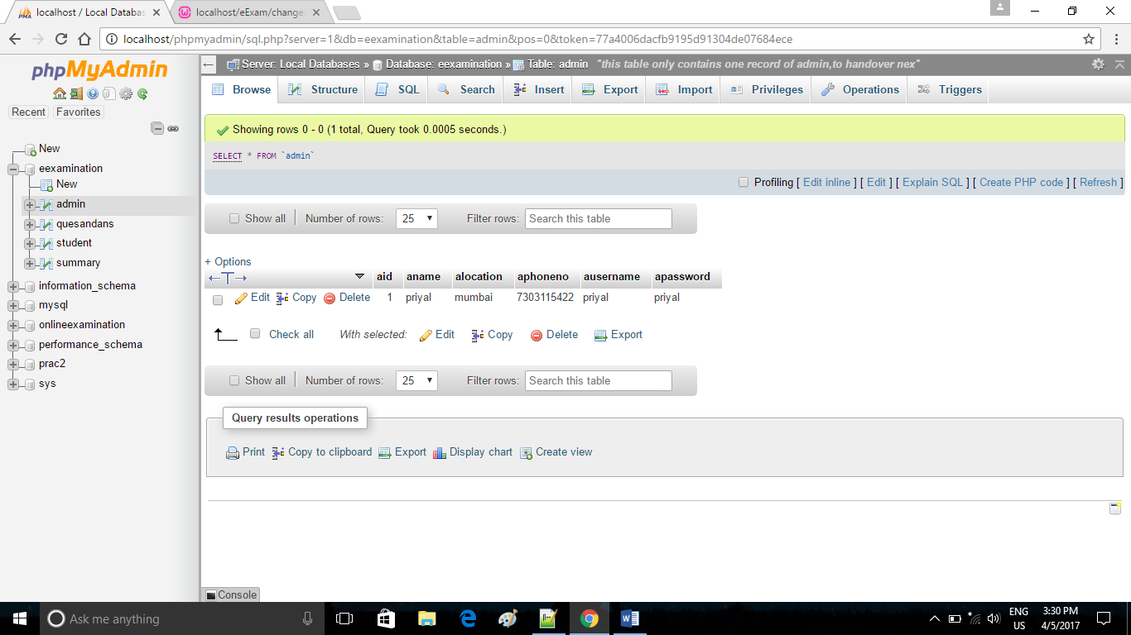

**CHANGE:** 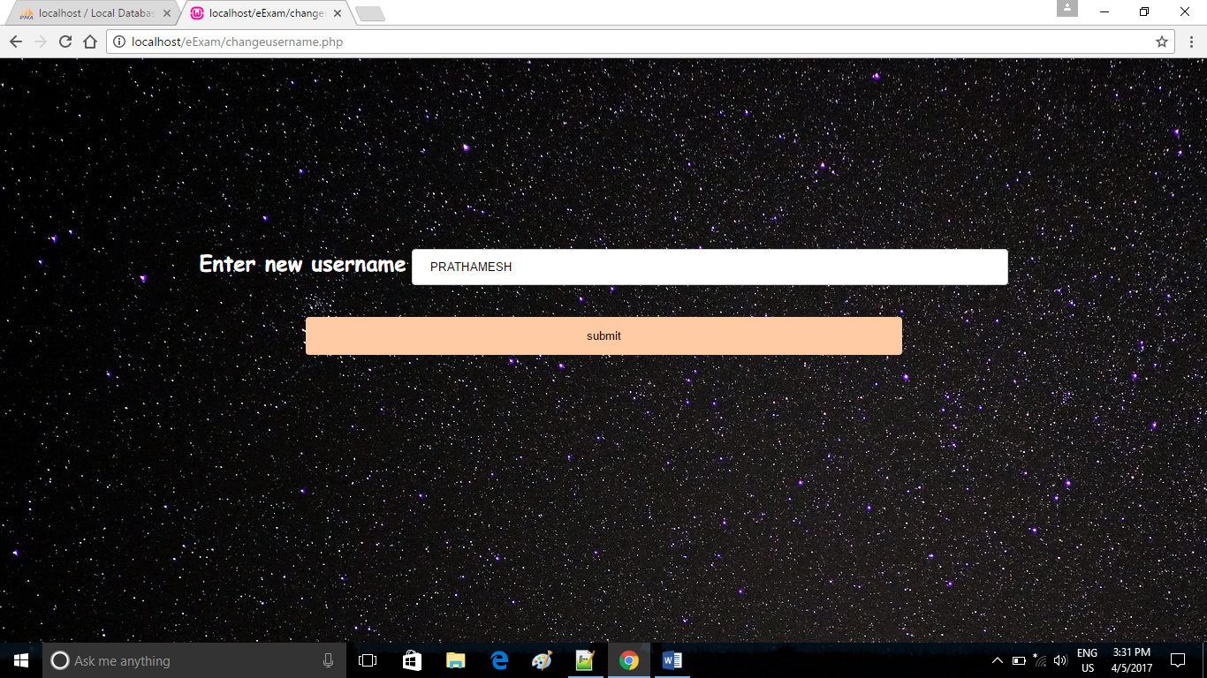

**AFTER CHANGE:**

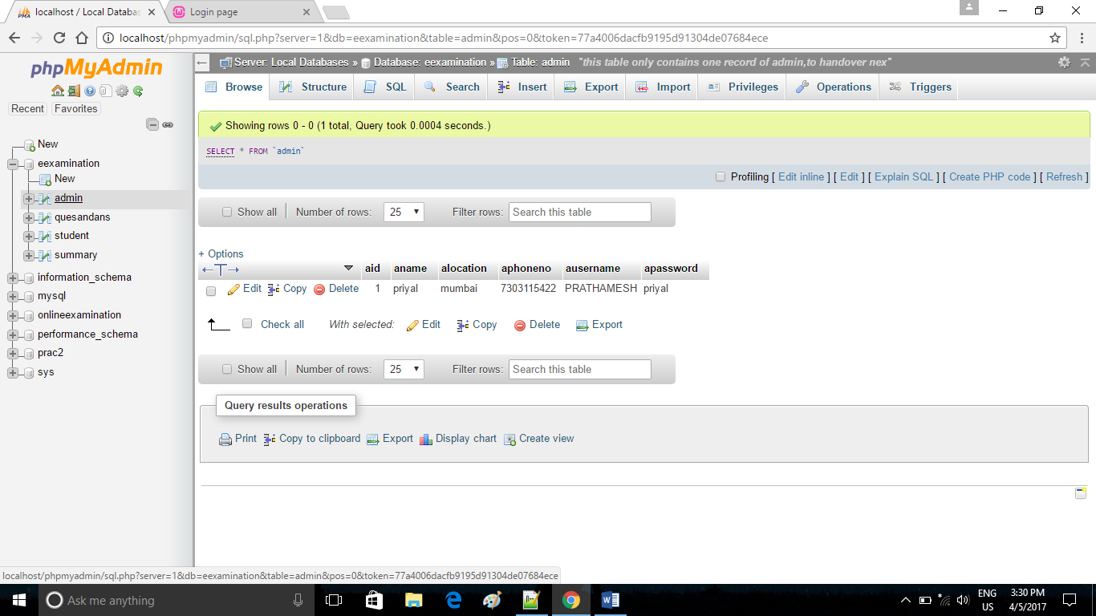

**22.Code for changing username in admin database**

<?php

if(isset($_POST['submitted'])){

include('connect-mysql.php');

$user=$_POST["username"];

$sql = "UPDATE admin SET ausername='$user' WHERE aid='1'";

if(mysqli_query($dbcon, $sql)){

echo "Records were updated successfully.";

header("Location: adminrights.php");

}

else {

echo "ERROR: Could not able to execute $sql. " . mysqli_error($dbcon);

}

// Close connection

mysqli_close($dbcon);

}

?>

**23.CHANGE PASSWORD**

**BEFORE CHANGE:**



**CHANGE:**

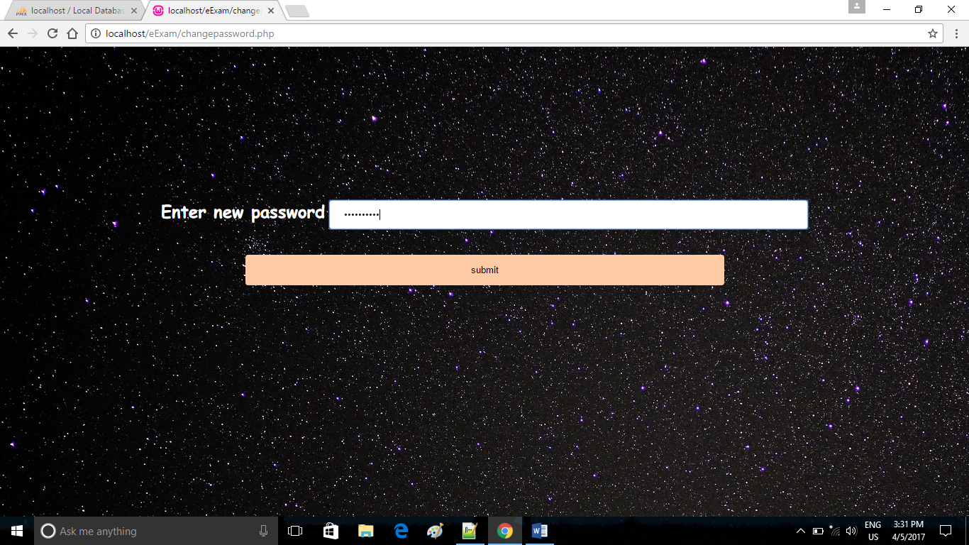

**AFTER CHANGE:**

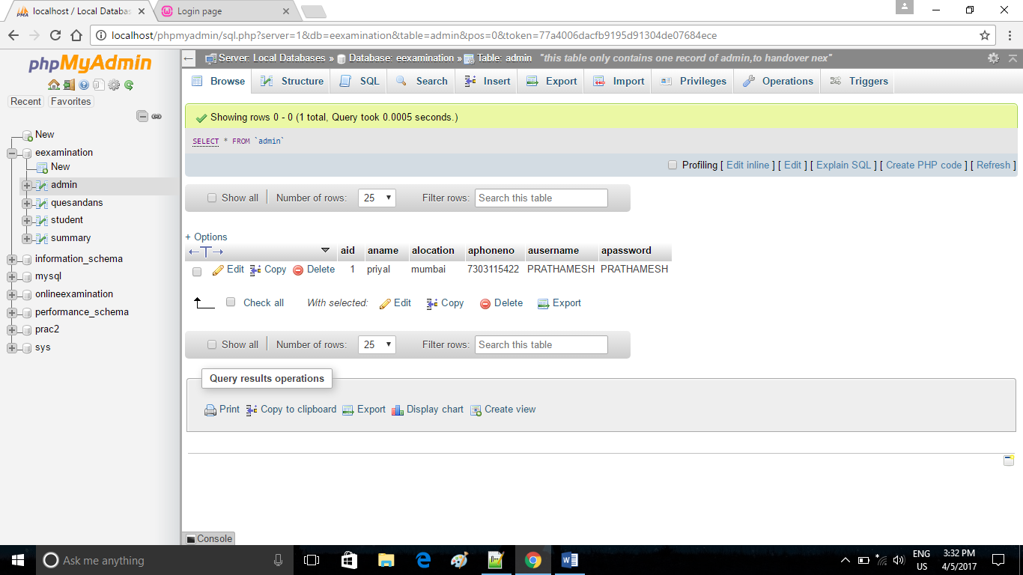

**24.Code for changing password in admin database**

<?php

if(isset($_POST['submitted'])){

include('connect-mysql.php');

$pass=$_POST["password"];

$sql = "UPDATE admin SET apassword='$pass' WHERE aid='1'";

if(mysqli_query($dbcon, $sql)){

echo "Records were updated successfully.";

header("Location: adminrights.php");

} else {

echo "ERROR: Could not able to execute $sql. " . mysqli_error($dbcon);

}

// Close connection

mysqli_close($dbcon);

}

?>

**25. SEARCH FIELD**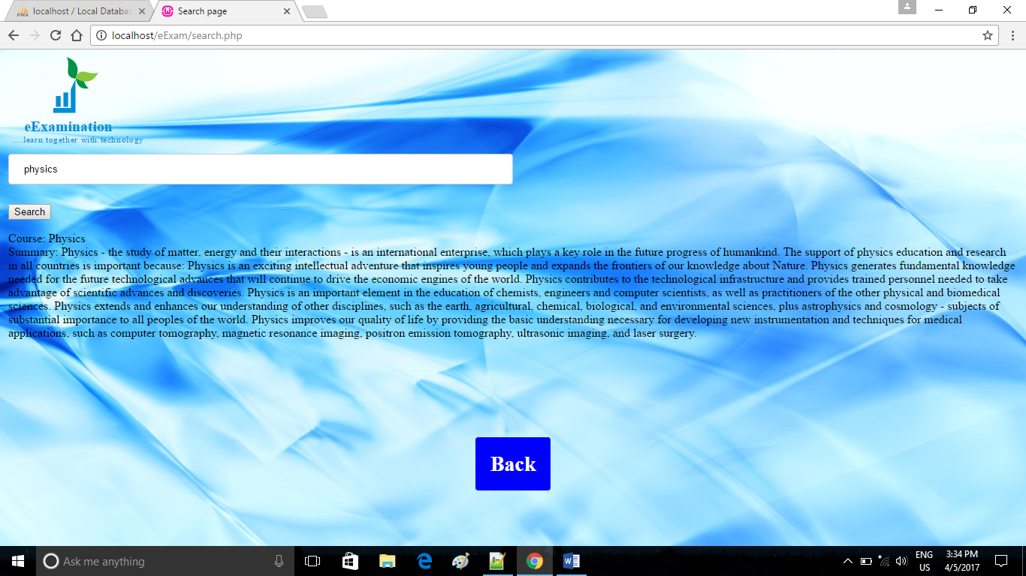

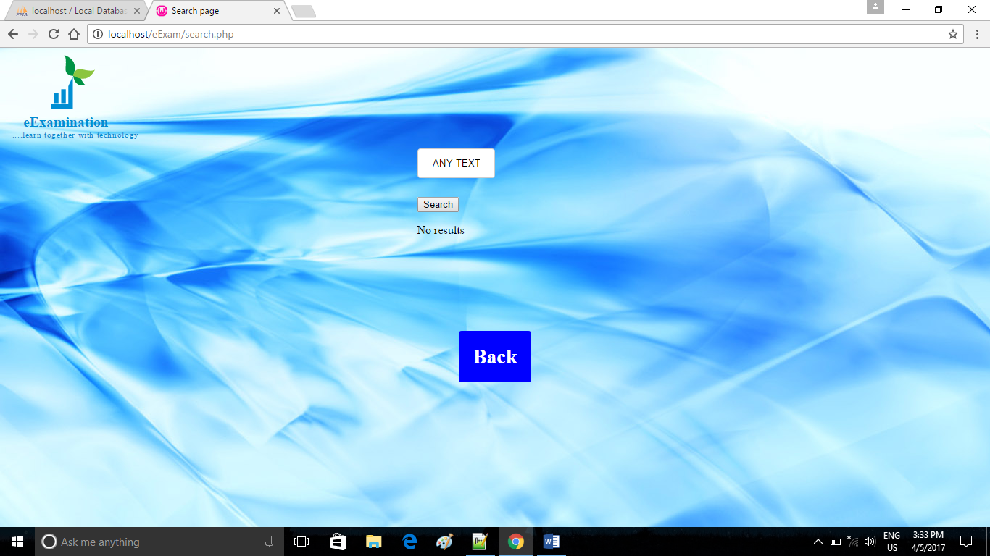

**26.Code for search field that searches data from database**

<?php

DEFINE('DB_USER','root');

DEFINE('DB_PSWD','');

DEFINE('DB_HOST','localhost');

DEFINE('DB_NAME','eexamination');

$output= NULL;

if(isset($_POST['submit'])){

//connect to the databse

$mysqli= mysqli_connect(DB_HOST,DB_USER,DB_PSWD,DB_NAME);

$search= $mysqli-> real_escape_string($_POST['search']);

$resultset = $mysqli->query("select * from summary WHERE Coursename ='$search'");

if($resultset -> num_rows > 0){

while($rows = $resultset->fetch_assoc())

{

$cname=$rows['Coursename'];

$summ=$rows['Summary'];

$output= "Course: $cname<br>Summary: $summ";

}

}

else{

$output= "No results";

}

}

?>

**Conclusion:** Hence, we have successfully implemented the mini project on Online Examination Portal.